Hello World RESTful Web Service - Spring Boot

Project Structure
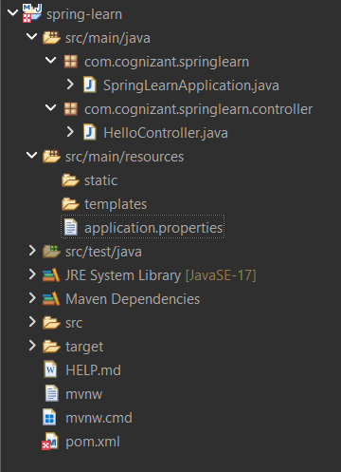

HelloController.java
package com.cognizant.springlearn.controller;
import org.slf4j.Logger;
import org.slf4j.LoggerFactory;
import org.springframework.web.bind.annotation.GetMapping;
import org.springframework.web.bind.annotation.RestController;
@RestController
public class HelloController {
private static final Logger LOGGER =
LoggerFactory.getLogger(HelloController.class);
@GetMapping("/hello")
public String sayHello() {
LOGGER.info("START");
String message = "Hello World!!";
LOGGER.info("END");
return message;
}
}

application.properties
spring.application.name=spring-learn
server.port=9090

Execution
Run SpringLearnApplication.java
URL:
http://localhost:9090/hello
